LAB SESSION 5
Programming Exercise:
Question 1: Find the sum of all elements in a 2D array.
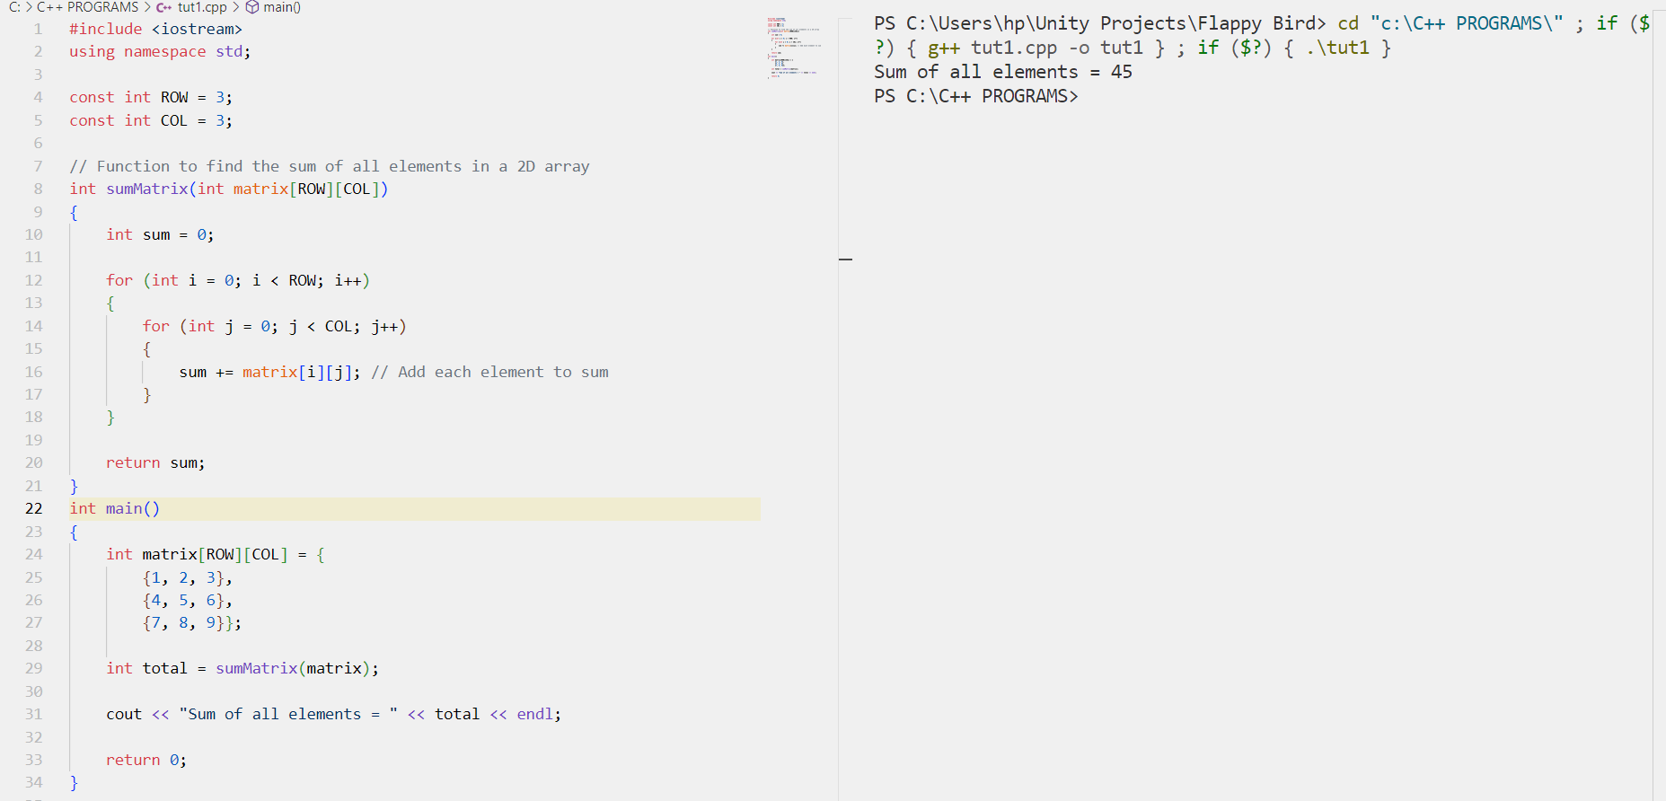

Question2: Calculate the transpose of a given matrix.
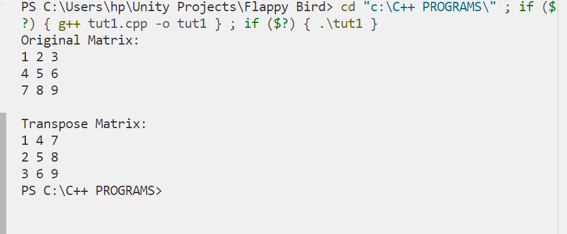
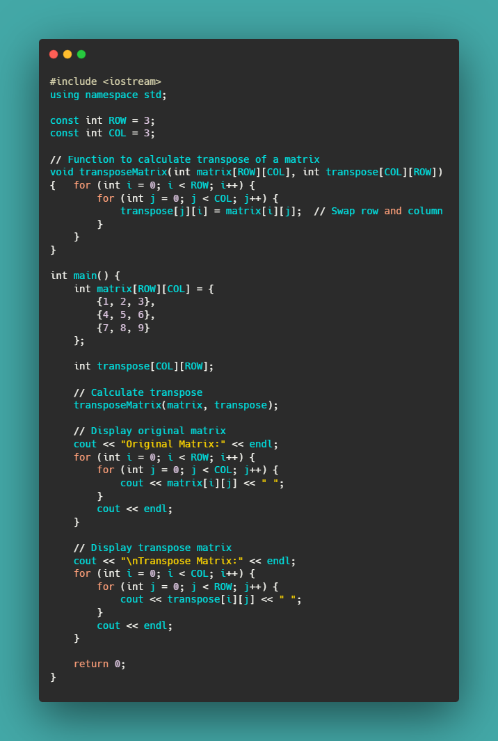
Question3: Check if a matrix is symmetric or not.
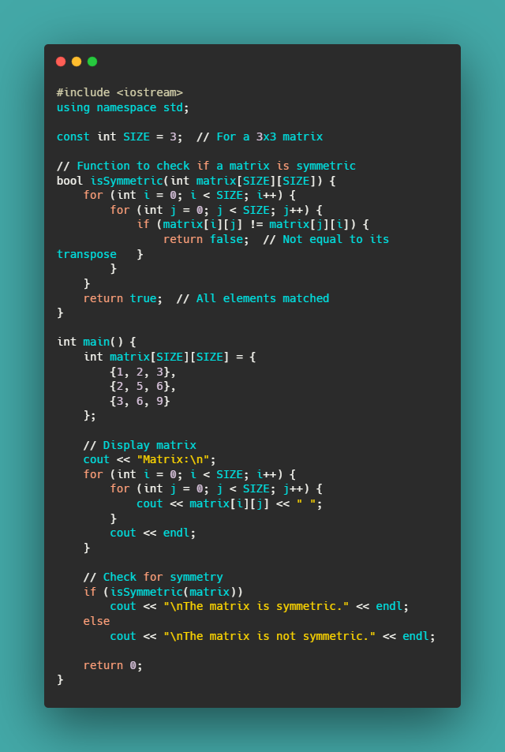
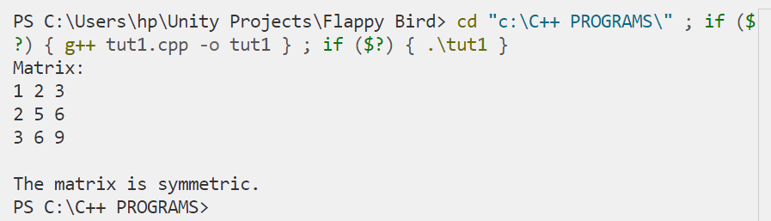

Question4: Multiply two matrices and print the result.
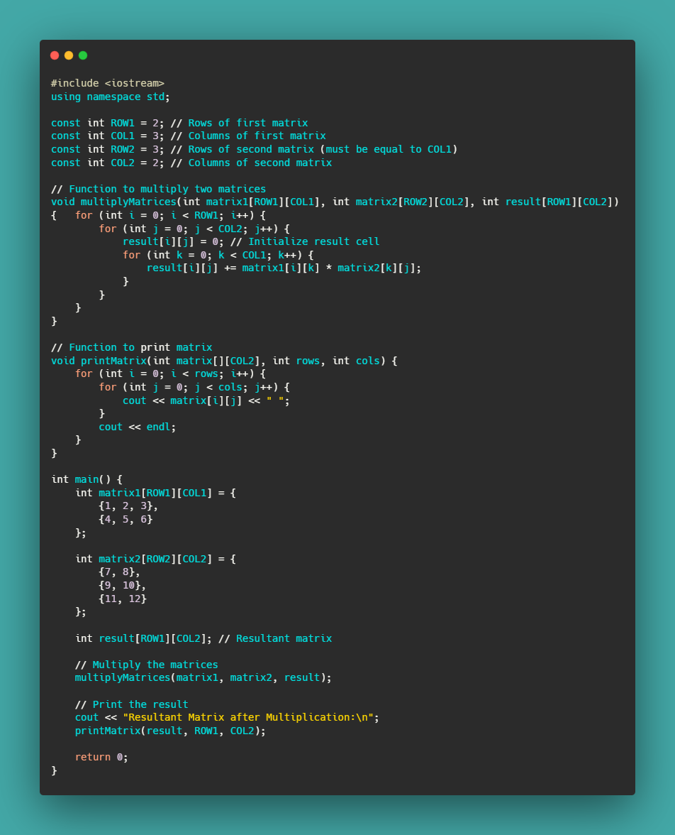
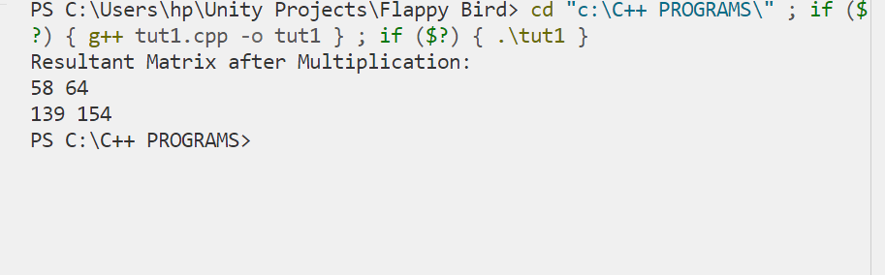
Question5: Find the largest element in each row of a matrix.
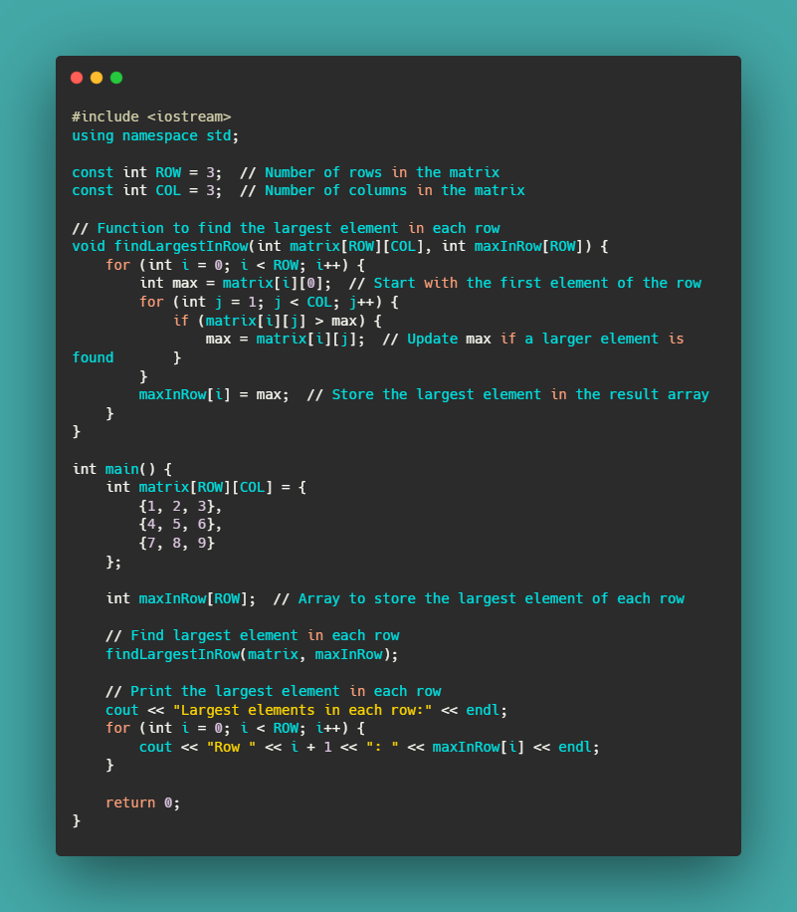
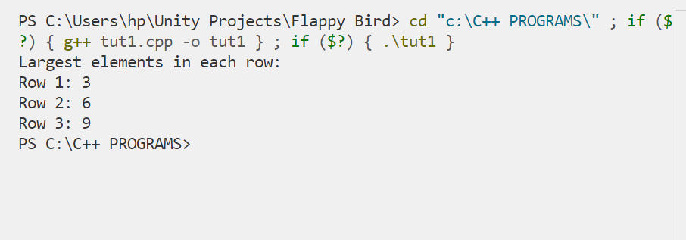
Question 6: Reverse the elements of a given vector without using the reverse() function.
